Exercise 2: Aggregation with GROUPING SETS, ROLLUP, and CUBE
Aim
To perform multidimensional data analysis using SQL aggregation features: GROUPING SETS, ROLLUP, and CUBE.
Problem Understanding
Sales reports often require summaries at different levels, such as by region, by product category, and overall totals. SQL provides advanced grouping operators to generate these summaries efficiently.
Tables Used
- Customers
- Orders
- OrderDetails
- Products
Implementation
- Joined the Orders, OrderDetails, Customers, and Products tables.
- Used GROUPING SETS to generate totals by Region, Category, and both Region and Category.
- Used ROLLUP to generate subtotals for each region and a grand total.
- Used CUBE to generate all possible combinations of Region and Category totals.
Difference Between GROUPING SETS, ROLLUP, and CUBE
Feature | Description
GROUPING SETS | Generates only the grouping combinations specified in the query.
ROLLUP | Generates hierarchical subtotals and a grand total.
CUBE | Generates all possible combinations of the specified columns along with the grand total.
Sample Output
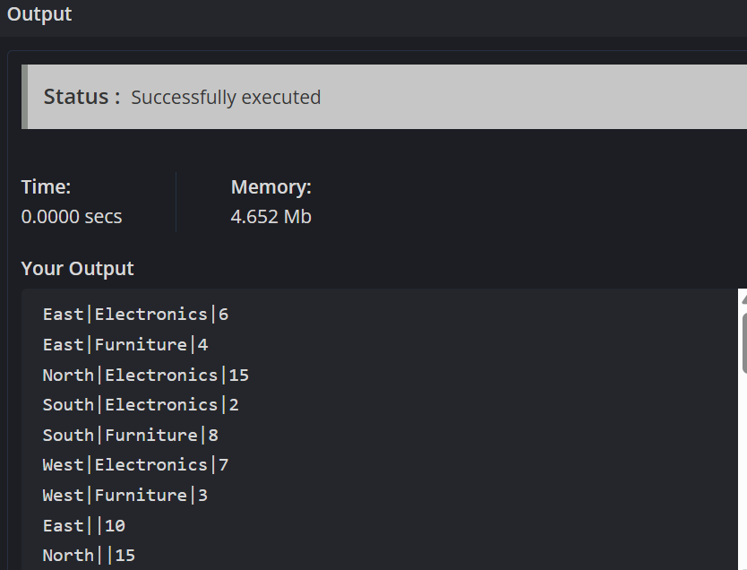
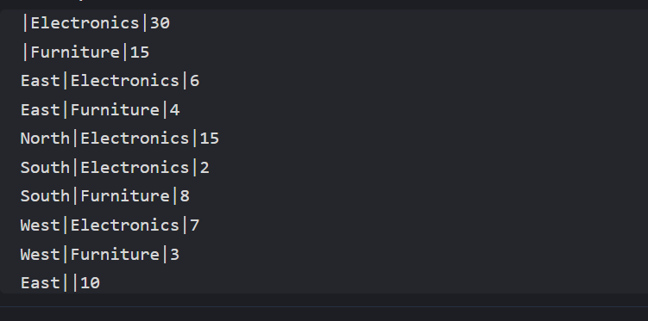
Conclusion
This exercise demonstrates how advanced SQL aggregation techniques can be used to generate detailed sales summaries. GROUPING SETS provides customized groupings, ROLLUP generates hierarchical subtotals, and CUBE produces all possible aggregation combinations for multidimensional analysis.

